***+ANUDIP FOUNDATION***

A Project Report on

**AI-Based Resume Screening**

By

Batch: ANP-D0453

Student ID: AF0477156

Name: Meena Durgam

**Under the Guidance of**

Mrs. Rajshri Chandrabhan Thete

AI-Based Resume Screening

Introducing our AI-Based Resume Screening:

The AI-based Resume Screening System is an intelligent solution designed to automate and enhance the hiring process. It uses artificial intelligence to analyse resumes, extract key information, and match candidate skills with job requirements. The system features a Bootstrap-based frontend for user interaction and a MySQL backend for secure data storage. By automating resume screening, it reduces manual effort, improves efficiency, and ensures fair and data-driven candidate evaluations, making recruitment faster and more effective.

**Entities:**

1. **User**
2. **Skill**
3. **Resume**
4. **Recommendation**
5. **Feedback**

**Attributes of Entities:**

**User**

* userId (Primary Key)
* userName
* email
* password

**Skill**

* skillId (Primary Key)
* name
* proficiency
* resumeId (Foreign Key)

**Resume**

* resumeId (Primary Key)
* filePath
* extractedText
* email
* resume_rank

**Recommendation**

* recommendationId (Primary Key)
* jobTitle
* jobDescription
* email
* resumeId (Foreign Key)

**Feedback**

* feedbackId (Primary Key)
* rating
* comments
* email
* resumeId (Foreign Key)

**ENTITY RELATIONSHIP DIAGRAM – AI-Based Resume Screening**

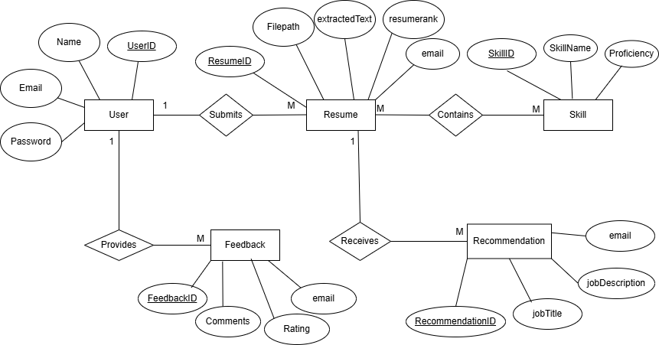

**CONCLUSION:**

In summary, The AI-based Resume Screening System is designed to streamline the hiring process by leveraging artificial intelligence to analyse resumes and provide insightful recommendations. The system consists of a user-friendly frontend built with Bootstrap, HTML, and JavaScript, allowing users to log in and submit their resumes. The backend is powered by MySQL, which efficiently stores user data, resumes, skills, feedback, and AI-generated recommendations. By integrating AI, the system extracts key information from resumes, matches candidate skills with job requirements, and generates relevant suggestions for recruiters. This automation reduces manual screening efforts, enhances efficiency, and ensures a fair and data-driven evaluation of candidates, ultimately improving the overall recruitment process.

**DATABASE CREATION QUERY:**

**mysql> CREATE DATABASE resume_screening_db;**

**Query OK, 1 row affected (0.02 sec)**

**mysql> USE resume_screening_db;**

**Database changed**

**mysql> CREATE TABLE User (**

**-> UserID INT PRIMARY KEY AUTO_INCREMENT,**

**-> Name VARCHAR(255) NOT NULL,**

**-> Email VARCHAR(255) UNIQUE NOT NULL,**

**-> Password VARCHAR(255) NOT NULL**

**-> );**

**Query OK, 0 rows affected (0.13 sec)**

**mysql> CREATE TABLE Resume (**

**-> ResumeID INT PRIMARY KEY AUTO_INCREMENT,**

**-> UserID INT NOT NULL,**

**-> FilePath VARCHAR(255),**

**-> ExtractedText TEXT,**

**-> ResumeRank INT,**

**-> FOREIGN KEY (UserID) REFERENCES User(UserID) ON DELETE CASCADE**

**-> );**

**Query OK, 0 rows affected (0.09 sec)**

**mysql> CREATE TABLE Skill (**

**-> SkillID INT PRIMARY KEY AUTO_INCREMENT,**

**-> SkillName VARCHAR(255) NOT NULL,**

**-> ResumeID INT NOT NULL,**

**-> FOREIGN KEY (ResumeID) REFERENCES Resume(ResumeID) ON DELETE CASCADE**

**-> );**

**Query OK, 0 rows affected (0.06 sec)**

**mysql> CREATE TABLE Recommendation (**

**-> RecommendationID INT PRIMARY KEY AUTO_INCREMENT,**

**-> ResumeID INT NOT NULL,**

**-> JobTitle VARCHAR(255),**

**-> JobDescription TEXT,**

**-> MatchScore DOUBLE,**

**-> FOREIGN KEY (ResumeID) REFERENCES Resume(ResumeID) ON DELETE CASCADE**

**-> );**

**Query OK, 0 rows affected (0.07 sec)**

**mysql> CREATE TABLE Feedback (**

**-> FeedbackID INT PRIMARY KEY AUTO_INCREMENT,**

**-> Email VARCHAR(255) NOT NULL,**

**-> FeedbackText TEXT,**

**-> Rating INT CHECK (Rating BETWEEN 1 AND 5)**

**-> );**

**Query OK, 0 rows affected (0.07 sec)**

**mysql> SHOW TABLES;**

**+-----------------------------+**

**| Tables_in_ResumeScreeningDB |**

**+-----------------------------+**

**| feedback |**

**| recommendation |**

**| resume |**

**| skill |**

**| user |**

**+-----------------------------+**

**5 rows in set (0.03 sec)**